PRACTICAL– 12 AI-Powered Software Testing

1. AI Prompt :
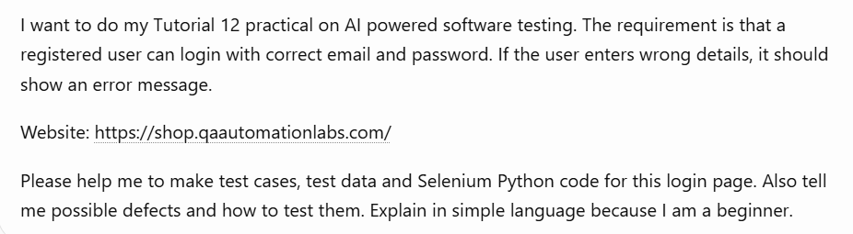

2. AI-Generated Test Cases :
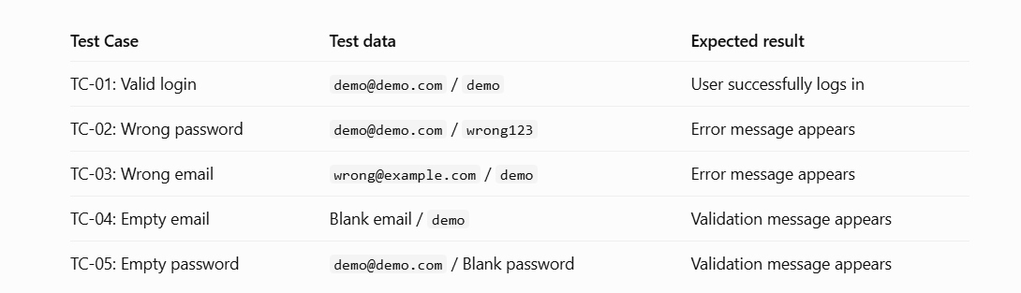

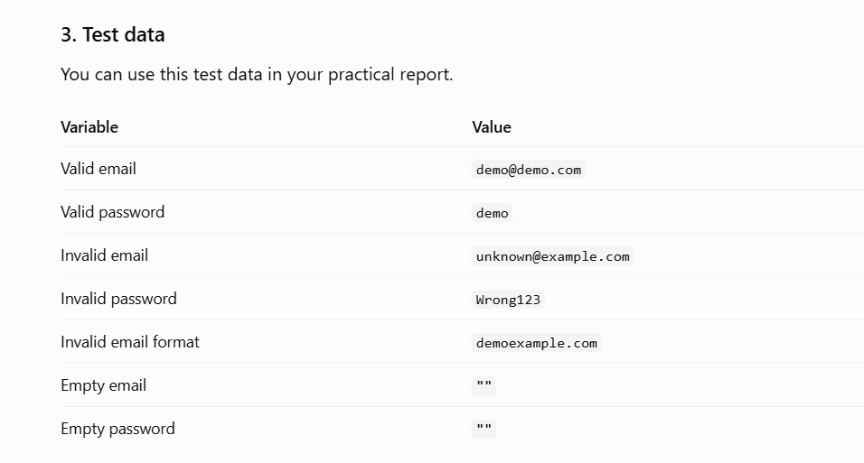

4. AI-Generated/Reviewed Selenium Code

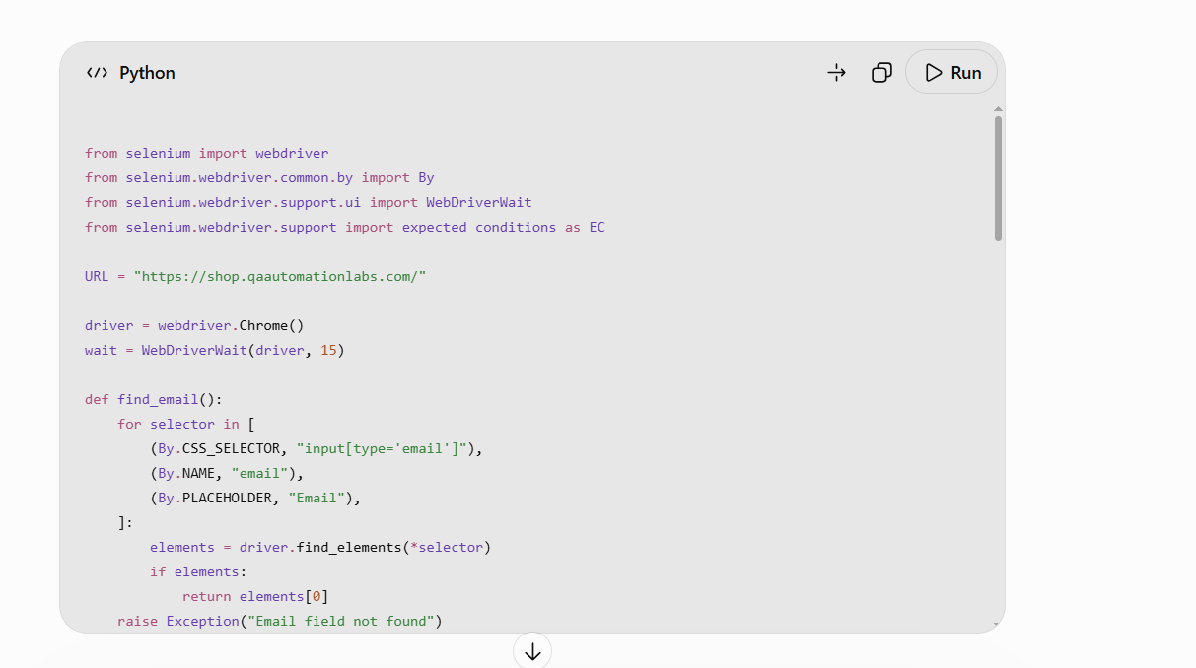

5. PyCharm Source Code

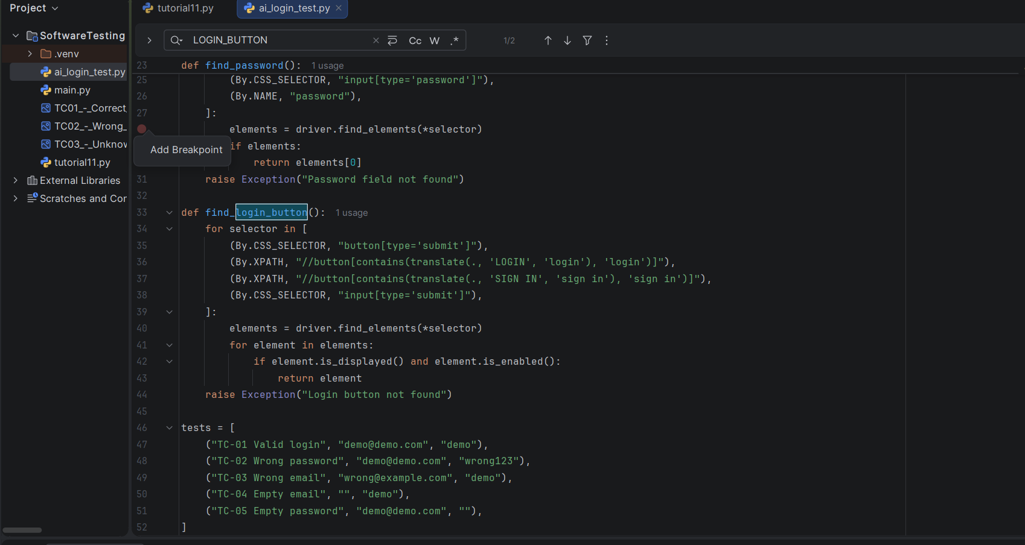

7. PyCharm Console Output

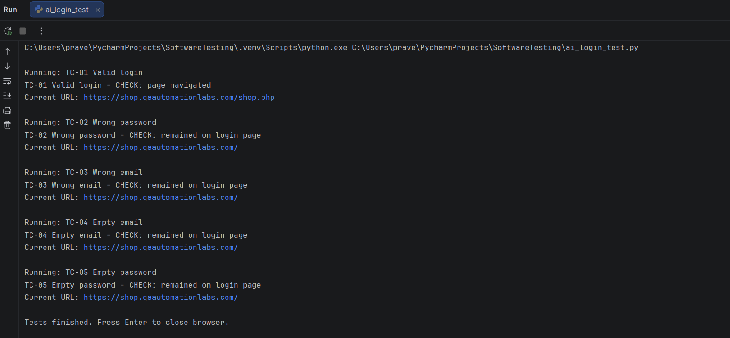
6. Browser Execution

